So could you develop a 4–5-page report structured around the following questions. You can share a draft with me by September 19.

(1) the i**mpact of digital technologies on hikers' interactions with wilderness settings**

**(more non hikers exploring, more unmarked trails (false sense of security), access to fragile areas, opposing view—disconnect, with—sharing experiences, diary)**

(2) the **impact of digital technologies (smartphones, social media, apps) on hikers' objective and subjective experiences in wilderness settings**

(subjective: social experiences—asocial experiences, planning and preparedness) (objective: measurable—hiking frequency?, hiking duration?)

(3) the **use of digital technologies by visitors in wilderness settings and outdoor environments (like parks and trails) and the impact on visitor experiences and perceptions, particularly social experiences**

(4) **how do park and trail managers use digital technologies**? What are their needs and motivations? What kinds of information would they like?

Using K Cluster

* Understand different approaches and perspectives of hikers, with a focus on tech use
* Questionnaire composed of two parts; first part is general quest (demographics and tech use), second part is would you rather questions
* From results created personas using K mode clustering
* Collected data was quantitative from response to ques and qualitative from feedback on discussions
* Observations:
  + People who carry 1-3 gadgets are in the group <18-30
  + People less than 30 were interested in tweeting while on the hike instead of going home and writing a blog
  + People above 51 are not much interested in carrying a smartphone or blogging about the hike on the spot
  + People who are interested in collecting data carried multiple gadgets, 67% of people are interested in carrying a smartphone and collecting data passively
* To identify personas, first they needed to cluster the data and based on the clusters, they were further divided into 6 groups to identify their characteristics
* Individual cluster analysis
  + 1. Age with Expenses
  + 2. Age with Activities
  + 3. Age with Gadgets
  + 4. Activities with Maximum expenses
  + 5. Activities with Frequency
  + 6. Activities with Motivation
  + 7. Activities with Gadgets
  + 8. comparing Gadget preference with Would you Rather question sections

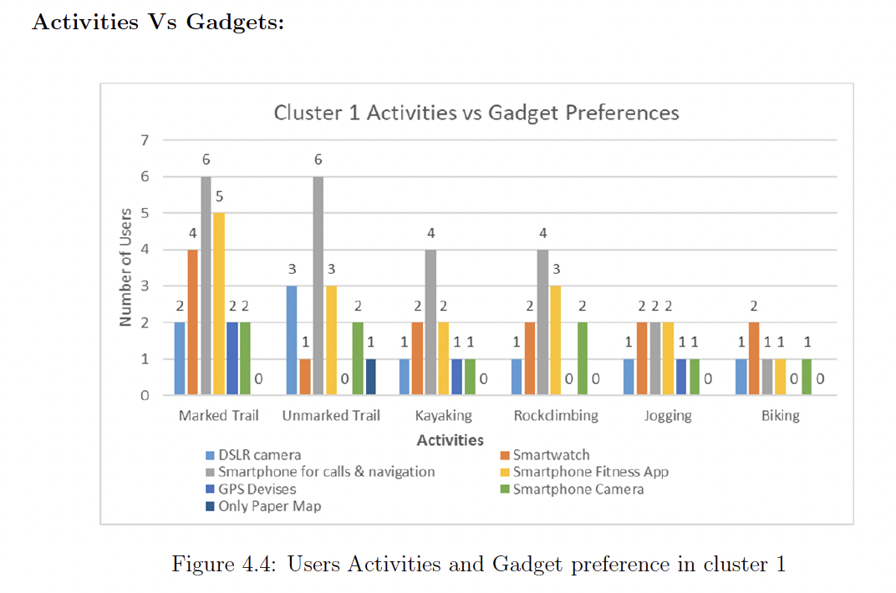

HCI outdoors

Walking as research

* Actively used on the move—navigation apps, infrequent Twitter, camera, voice recorder, wrist-watch-style heart rate devices (for consulting while moving), iPods and MP3 players.
* Passively gathering/transmitting data—SPOT and ViewRanger transmitted my location to online maps, biosensors, many now wear Nike Bands, or similar devices.
* There for emergencies/occasional use—mobile phone there in case of need, or maybe to be available to others if they need to contact you, the SPOT device had an SOS button, which would call emergency services if needed.
* Used during breaks—often this may be in places with better connectivity and under cover, for example, I used an iPad mini extensively for writing if I stopped in a cafe. People may use mobile Internet (where available) to book accommodation, or may use a rest gap to post statuses to social networks (signal allowing).
* Used outwith the walk—some technology is used before walking for planning, or afterwards for reminiscing, uploading photos, etc.
* Challenges regarding tech (battery and signal)

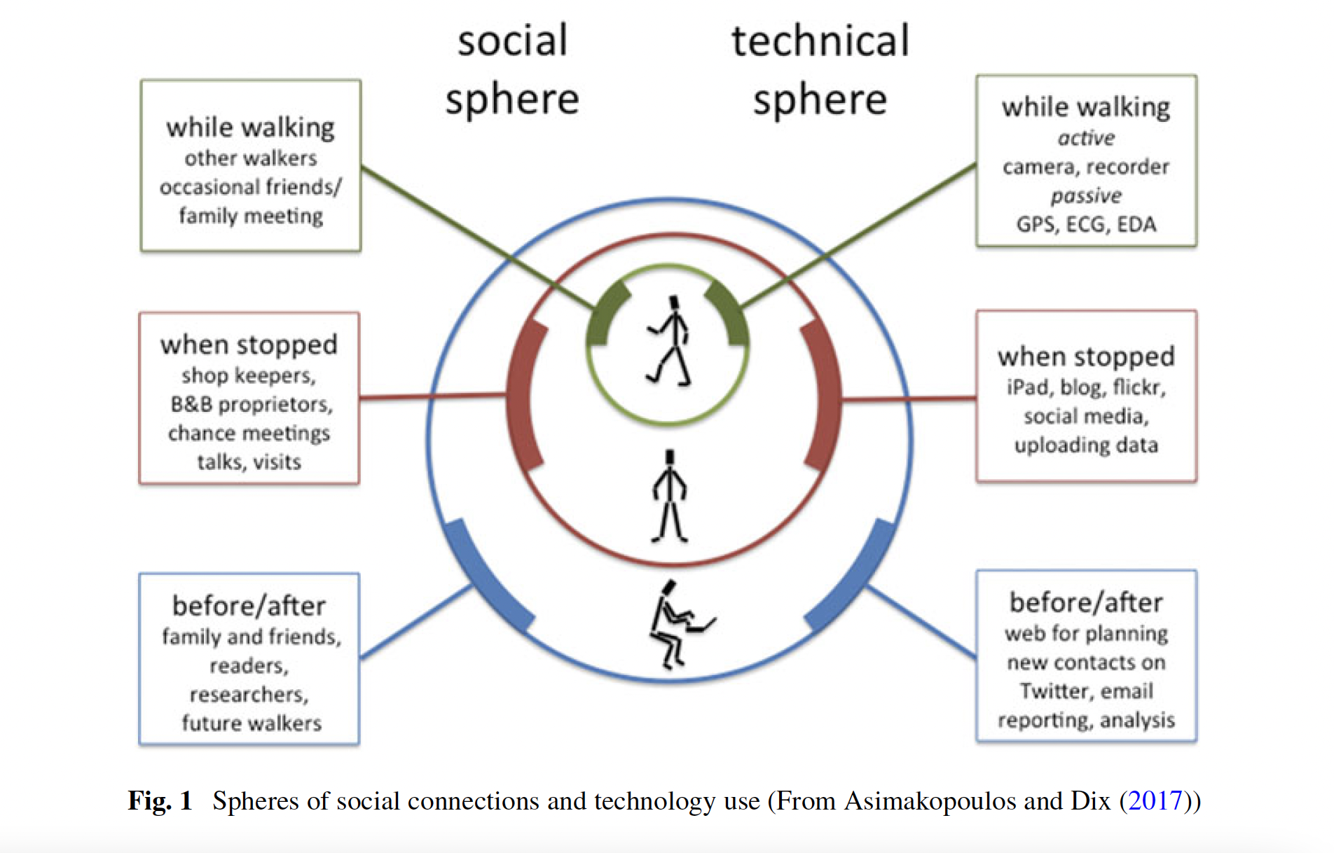

Opportunities in conflict on trail

* Identifying who’s on the trail (split into clusters), identified through a workshop

Re-thinking the role of mobile computing in rec hiking

* Quantitative survey, 95% of respondents bring a cell phone
* Different scenarios (including leaving phone in bag to avoid distractions)-most distracting is email, notifications, SMS and social media

Location based services

User requirements for LBS to support hiking

* 1. What type of unexpected changes may occur during the hike and what needs these situations cause for the hikers? What type of support actions would help hikers to recover from and adapt to these sudden changes?
* 2. What type of community and content needs the hikers may have while hiking? Are there some beneﬁts that LBS could offer; for example; what type of needs do hikers have in relation to creating and sharing their own content while hiking? What kind of content should be provided for them, and how could it be used while carrying out an outdoor activity? How would hikers beneﬁt from knowing the location and other information about the other hikers?
* Nine thematic categories
  + • Planning a hike
  + • Additional information on the area
  + • ‘I am here’ services
  + • Location of other hikers
  + • Changing conditions
  + • Emergency situations
  + • Saving experiences
  + • Sharing experiences
  + • Integrated and adaptive services
* 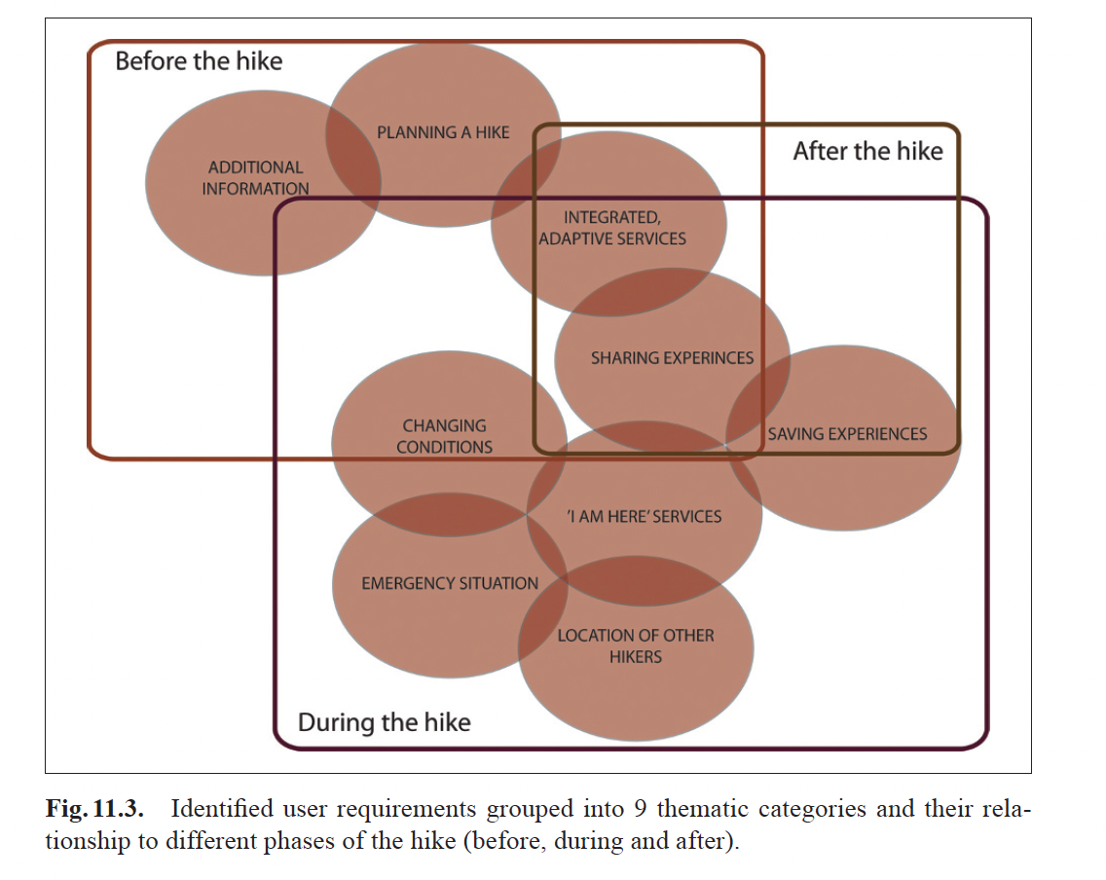

An Analysis of Hiker Preparedness: A Survey of Hiker Habits in New Hampshire

* Using the HikeSafe program as a template, our study constructed a survey evaluating hiker preparedness. Speciﬁcally, the survey investigated our initial hypotheses regarding hiker habits: 1) The majority of hikers will not be carrying all of the 10 essentials listed in the HikeSafe program. 2) Mobile phones and Global Positioning Systems (GPS) will encourage hikers to choose trails more difﬁcult than they would have otherwise attempted. 3) Most hikers will not inform others of their travel plans
* HikeSafe guidelines discourage GPS substitution for map and compass because the WMNF is notorious for poor signal reception, particularly with smart phone-based GPS.4 Thus, carrying a GPS device was not counted as satisfying the “map” or “compass” essentials.
* Table 2 describes aspects of planning for hiking trips. The majority of hikers planned to be out less than 12 hours, had checked the weather, and informed another of travel plans. Hikers planning trips shorter than 12 hours were less prepared compared with those planning longer trips. If hikers did not inform a third party of travel plans, it was most often because they “didn’t think it necessary.”
* Table 3 describes types of and opinions regarding communications devices carried. The majority of hikers carried communications and GPS devices. However, most hikers had GPS access via smart phone rather than through a dedicated GPS device. Smart phone GPS users were less prepared than dedicated-device GPS users.

Whither wilderness? An investigation of technology use by long-distance backpackers

* 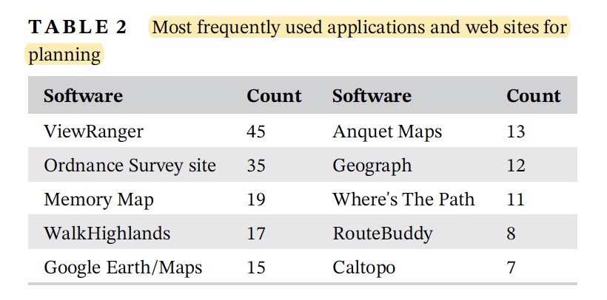
* 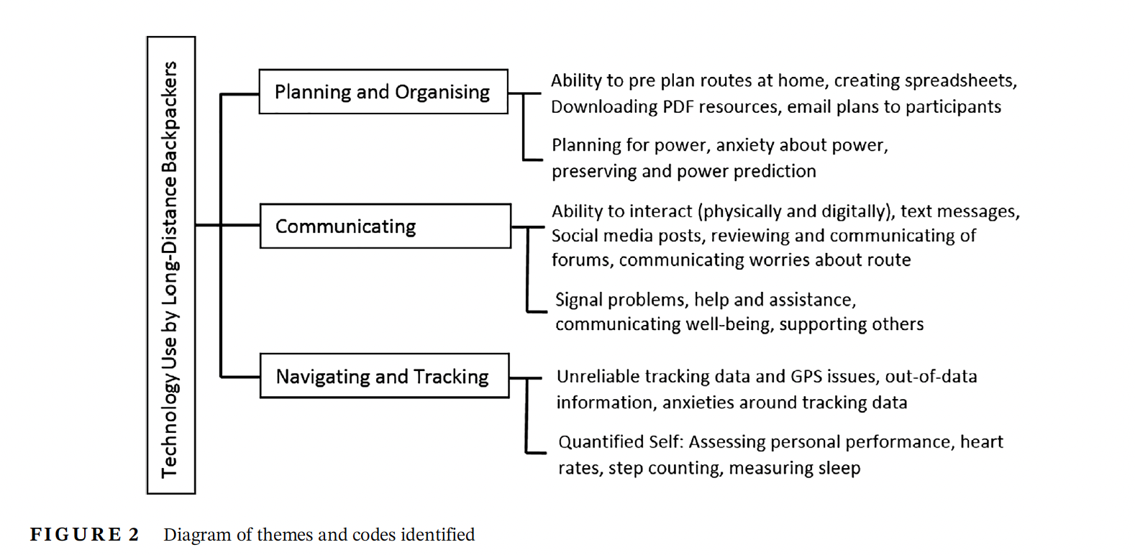

Towards Understanding Hikers’Technology Preferences

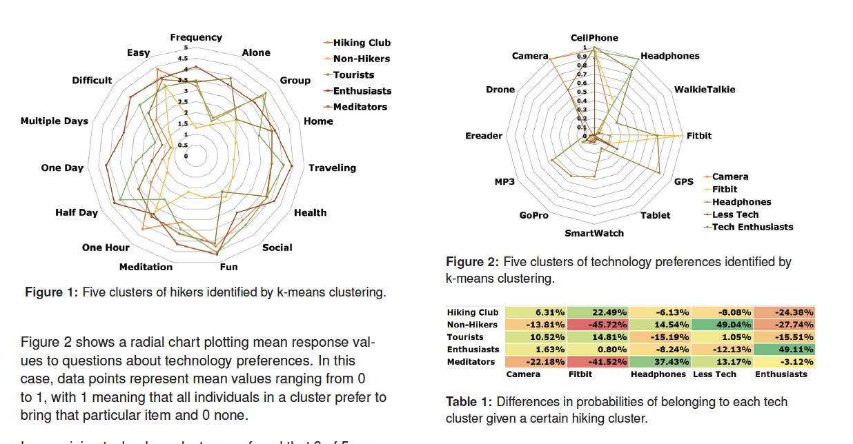

* Hiking Clusters and Potential Characterizations
  + Cluster 1—Hiking Club: Members of this group like to take a short easy hike roughly once a month in a group with fun being the strongest motivator.
  + Cluster 2—Non-Hikers: Members of this group don’t seem to enjoy hiking, and apparently would prefer short and easy if they must do so.
  + Cluster 3—Tourists: Members of this group enjoy hiking while traveling with a group of people and hikes that last half a day.
  + Cluster 4—Hiking Enthusiasts: Members of this group enjoy hikes of all lengths and difficulties, at home and traveling, and for all motivations.
  + Cluster 5—Meditators: Members of this group enjoy taking frequent hour to halfday hikes alone with health and meditation being the strongest motivators.

Walking: A Grounded Theory of Social Engagement and Experience

* Tech & products for walking
  + Twitter, as an example of social media, was virtually impossible to use mainly due to the tendency to discard messages
  + cameras and audio recorder have had a low impact on the walking experience,
  + PS devices or phone apps were com-monly used for navigation by people including experienced hikers (see Mason et al., 2013).
  + Hobbit (Posti et al., 2014), which deliberately highlights routes that are infrequently walked or away from other users to seek solitude, again inverting the focus on social networking and hyper-connectivity
  + mobile-phone applications (e.g. http://www.viewranger.com/) that help navigate or capture experiences in the wild.
  + others enable connections with social media and other information sources, such as Social Hiking (e.g. http://www. shareyouradventure.com/).
  + Nike+, Jawbone and FuelBand can be used independently, but actively encourage sharing of activity data in order to encourage competition: ‘Sync with your device, see your progress and compete against your friends’
  + e mobile-phone-based research application HeartLink takes this a stage further enabling a live two-way interaction (Curmi et al., 2013). HeartLink con-nects to a commercial chest-strap heart sensor and transmits live heart-rate information to friends and supporters. In turn they can ‘cheer’ the wearer,
* intrinsic motivation and individual goals that are the main determinants of behaviour (Spillers and Asimakopoulos, 2014).
* Dimensions of experience;
  + Synchronous (real time) eg SPOT
  + Asynchronous eg blogs
* Communities of experience
  + Egocentric/people of life – These are the walker’s own individual community, linked to his personal existence. They are stable and long-standing, and largely geo-graphically stationary but widely distributed.
  + Geocentric/people of the land – These are the local com-munity, people who live in the towns and places along the way. They are linked to a speciﬁc place. The rela-tionships are typically ﬂeeting, but the people them-selves are largely geographically stationary and localized to the route of the path.
  + Tribocentric/people of the way – The walking commu-nity, who are connected to the path, not any particular place along it. The meetings are ﬂeeting and the people themselves geographically dynamic.
* the walker carried a lot of technology. However, the GT analysis of the blogs, reported in sec-tions 3 and 4, ends up highlighting social rather than technological relationships. This is partly because of the prac-tical difﬁculties of using technology,